Contents

AZURE WEB-APP SERVICE 2

AZURE APP SERVICE PLAN 2

TYPES OF APP SERVICE PLAN 2

CREATING AN APP SERVICE 4

SIMPLE CHANGES IN THE WEB APP 4

DEPLOYMENT SLOTS 5

CREATING A DEPLOYMENT SLOTS 5

AUTOSCALING THE AZURE WEB APP 7

IMPLEMENTING AUTOSCALING THE AZURE WEB APP 7

# AZURE WEB-APP SERVICE

|  |  |
| --- | --- |
| * Web App Service is a platform-as-a-service where the undelying infrastructure is managed ny Azure itself. * This is an HTTP-based service used for hosting web applications. * The web application can developed in languges like .NET, .NET Core, Java, Ruby, Node.js or Python which can run on Windows or Linux-based platforms. * Since is a PAAS, the application gets deployed on an underlying compute infrastructure (VM). The entire infrastructure is managed by Azure themselves i.e., by the Azure App Service. * Azure webapps has a features such as auto scaling and security and DevOps capabilities |  |

## AZURE APP SERVICE PLAN

* App service plan defines the set of compute resources that are used to run the web application
* When we create a web app in Azure, we need to create something known as the App Service Plan. Hence the Web app service are always linked to an app service plan.
* The billing of an app service depends upon the type of app service plan that we choose ( <https://azure.microsoft.com/en-us/pricing/details/app-service/windows/#pricing> )

### TYPES OF APP SERVICE PLAN

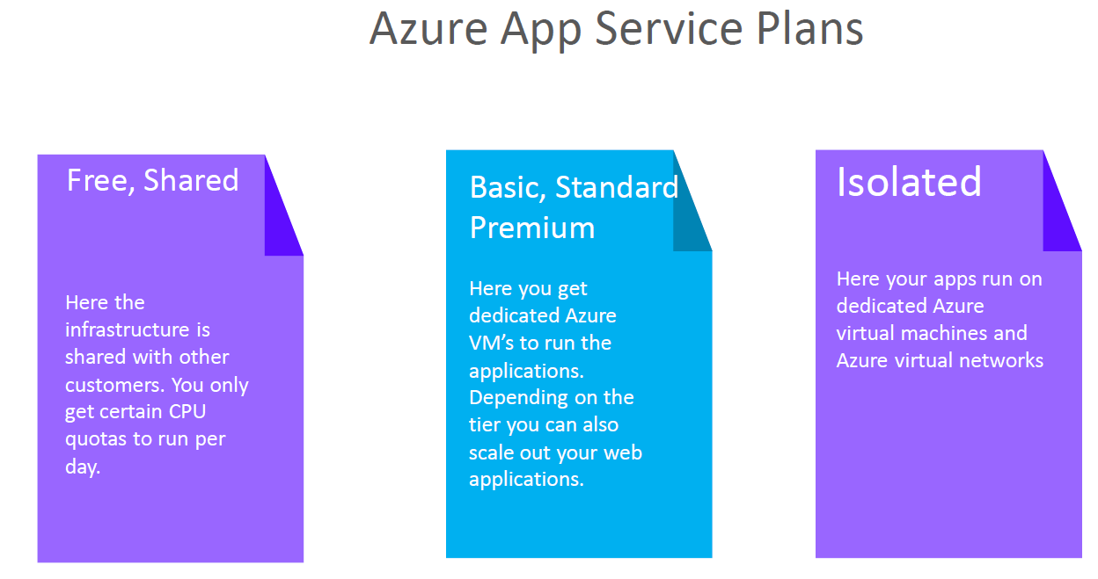

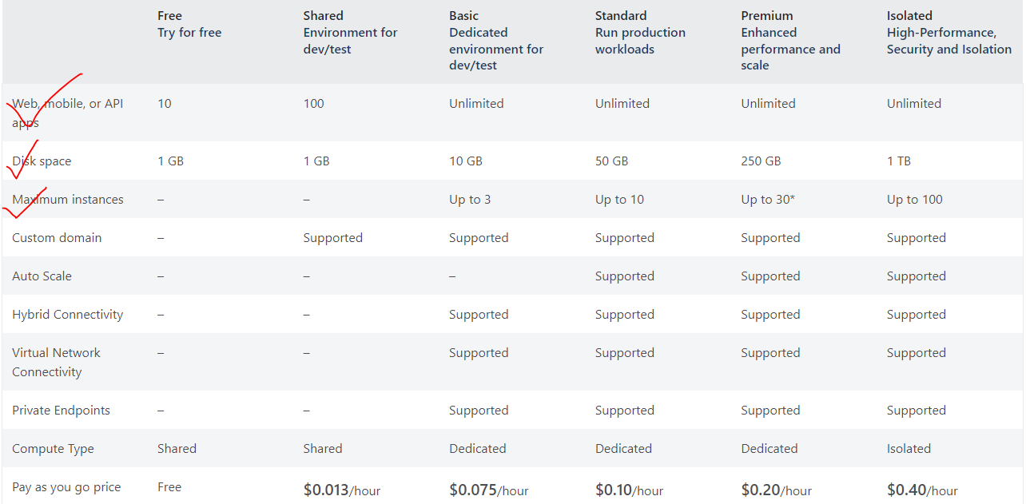

* In the above pricing table of app service plan show different features associated with different App service plans.

#### UNDERDTANDING THE BASIC APP SERVICE PLAN

|  |  |
| --- | --- |
|  | * In Basic plan we can deploy unlimited web app and storage capacity of 10 GB in total. We can be able to scale up to 3 VM instances. * Let's say we create an Azure app service plan (basic pricing tier). * In this plan - we can create unlimited Azure Web applications and link it to the app service plan, * As Azure Web app service is a PAAS so the infrastructure that is required for hosting the Web applications get created as well   **USE CASE**   * Let's say that the app service plan created one compute instance to host two Web applications, * Now after that - we add a third Web application. If the compute instance is not enough to withstand the load of all of the three web applications. * As per the basic plan – the underlying VM can scale up to 3 instances. Hence now application can be distributed across these compute instances and the load gets distributed accordingly.   **NOTE**   * We don't have to create multiple app service plans – we can have one App service plan and have multiple Web applications as part of that app service plan. * But this decision also depends on what is the underlying Programming language for that Web application. For example, we can create an app service plan that spins up Windows based virtual machines. This Windows based virtual machine will not be able to run applications that are dependent on Linux, if we want to host Linux based web applications, then we need to create another separate app service plan. |

## CREATING AN APP SERVICE

* Select “Web App” Service

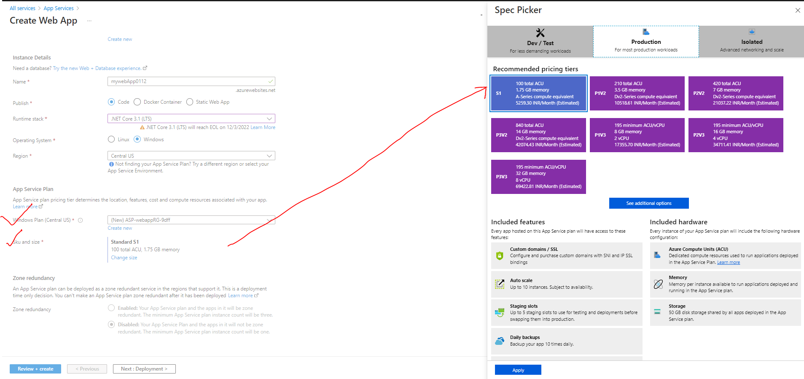

|  |  |
| --- | --- |
| NAME | Unique name of the app. By default, azure append a default DNS name to the web app. We can have custom DNS name as well. |
| PUBLISH | Type of App |
| RUNTIME STACK | Runtime of the of application is going to be hosted |
| OPERATING SYSTEM | The operating system that will be installed on the underlying VM which will host the webapp |
| WINDOWS PLAN | * While create a web app – an app service plan is created. * We can also to link it the web app to the existing app service plan |
| SKU / SIZE | * Here we select the type SKU/ Size available for a given app service plan |

* This creates 2 resources i.e the App service and App service plan. Now if we want to create a another web app (which will use the same underlying OS ), then we can make use of same app service plan



* Once the setup is done. Azure will host a default “.NET Core” based application on Azure webapp service. For our case it can be accessed at - <https://mywebapp0112.azurewebsites.net>

### SIMPLE CHANGES IN THE WEB APP

* For making small scale changes we can make use of App Service Editor. For example – updating an­­­­­­­ existing HTML, adding new HTML files etc.

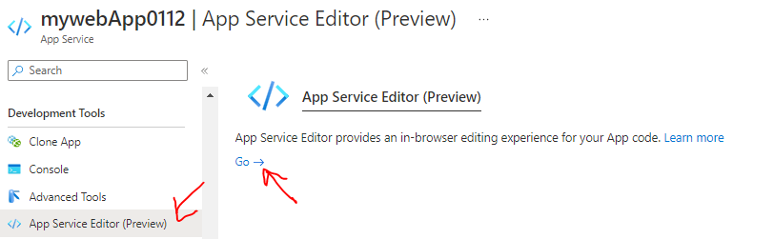

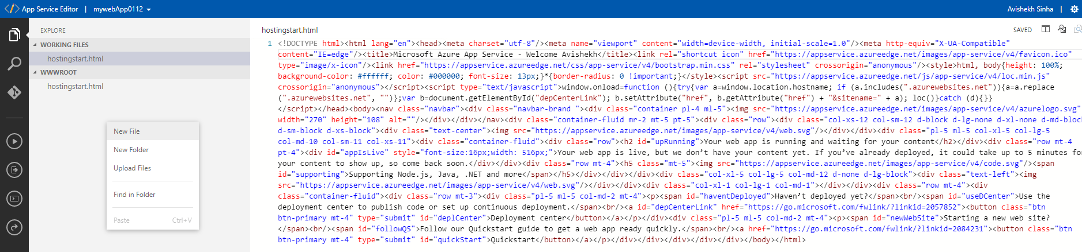

## DEPLOYMENT SLOTS

* Azure deployment slots allow us to run multiple versions of the application code on the same infrastructure.
* For example- Let's say we have a web application (*MyWebApp*) deployed in azure. By default, it gets an URL (mywebapp.azurewebsites.net). Considering it as our production version of the application then users are able to access and use it.
* Now, let's say we need to make a change to the application. (Maybe, there is a bug or adding a new feature). After the change we want to test these changes in production like environment.

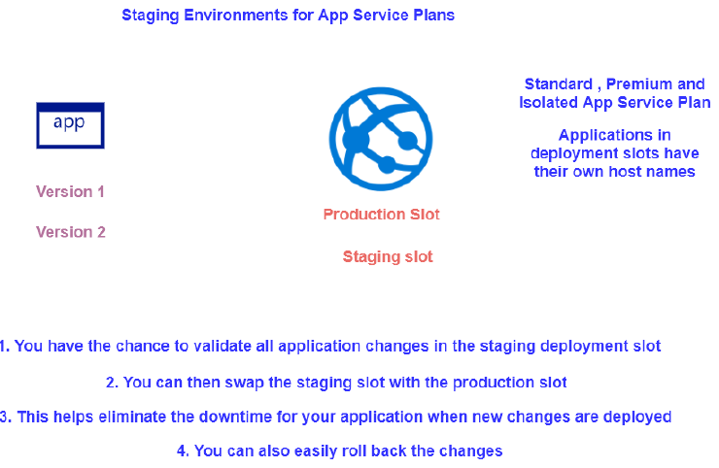

|  |  |
| --- | --- |
| azure staging slots | * We can create a deployment slot and deploy the changed version of our application. For example, if we name the deployment slot - staging, then we get the following URL. - mywebapp-staging.azurewebsites.net * The new version of the app is now in the staging slot. It gives you an opportunity to test your application. If you are happy with the changes, you simply swap the staging deployment slot with the production deployment slot. |

### CREATING A DEPLOYMENT SLOTS

* To make use of deployment slot, the app service plan attached to the web app service should be Standard or higher. Note – we can be able to update the existing app service plan using “Scale Up” option
* Let’s say we already have a web app tied to a Free app service plan, to update the app service plan – we can make use of Scale up option.

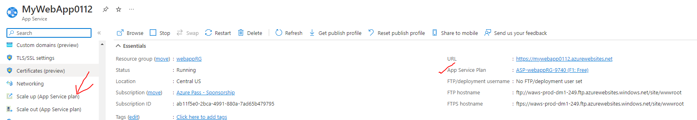

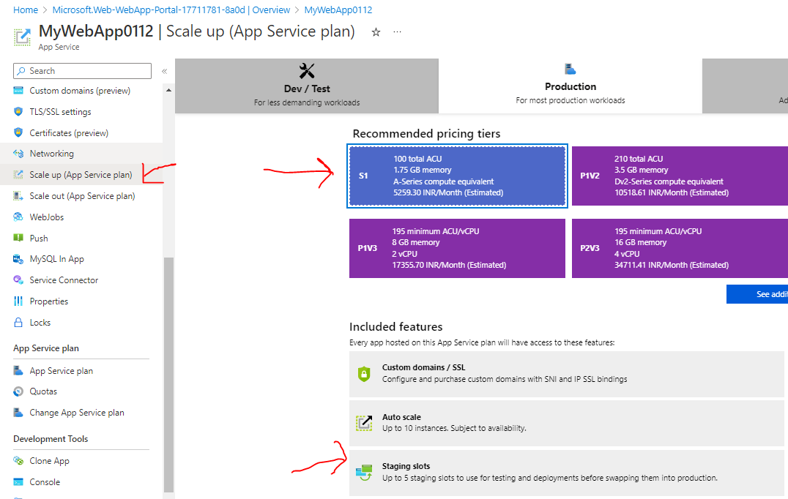

PROD VERSION OF APPLICATION

* ***PROD URL (prod version)***- <https://mywebapp0112.azurewebsites.net/>

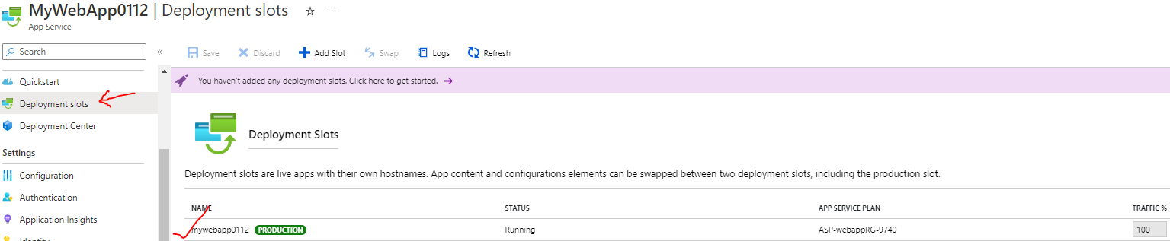

STAGE VERSION

* To deploy the newer version of the application as a new web app – In this app itself, we can create a deployment slot
* ***STAGE URL(new version)*** - <https://mywebapp0112-stagging.azurewebsites.net/>

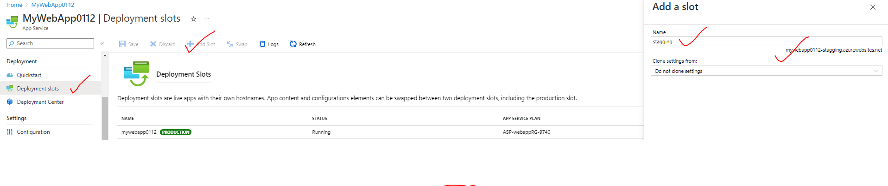

SWAPING

* Once the testing is done of the newer version. We can now swap the deployment slots . Hence the PROD version will become STAGE version and vice versa.

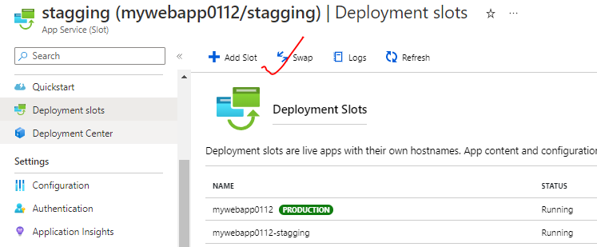

## AUTOSCALING THE AZURE WEB APP

* We get the autoscaling feature if the app service plan is *Standard App Service plan or higher*.
* The autoscaling feature is useful when the traffic increases to the webapp.
* Scaling up add more compute resources which help in distributing the load across these virtual machines.
* Note –
  + The basic up service plan, we scale up to three virtual machines but it’s a manual procedure
  + For auto scaling we need to choose the standard service plan or higher.
* We need to create rules and conditions to trigger the scaling process. For example, we can create a condition based on the percentage of the underlying compute infrastructure
  + Example - if the C.P.U goes beyond a particular limit, we can scale out the number of machines automatically.
* If the load decreases, it should scale in the number of virtual machines.

### IMPLEMENTING AUTOSCALING THE AZURE WEB APP

* For basic app plan – We can do only manual scaling

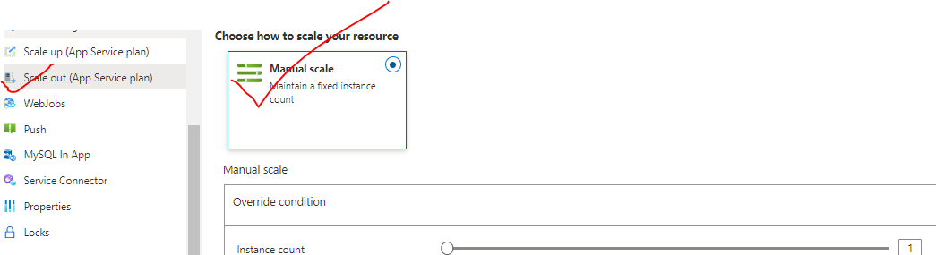

* For Standard and higher app plans – auto scaling feature is available.

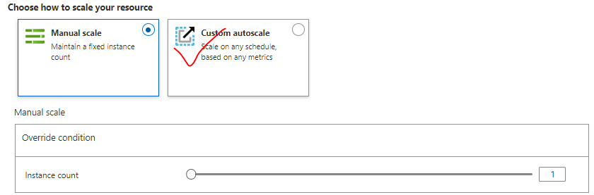

#### AUTOSCALING CONDITON